
Haworth’s detectives

Most museums and art galleries are in really interesting buildings. Some are hundreds of years old. Others are modern. Look at the architecture before you go inside…

Does it look old or new?

Is there a date?

Is it symmetrical? (Does one side look the same as the other?)

What materials were used to build it? What do they feel like?

Are there any carvings?

What’s the most interesting bit?

Do you like the design?

Does it echo when you go inside?

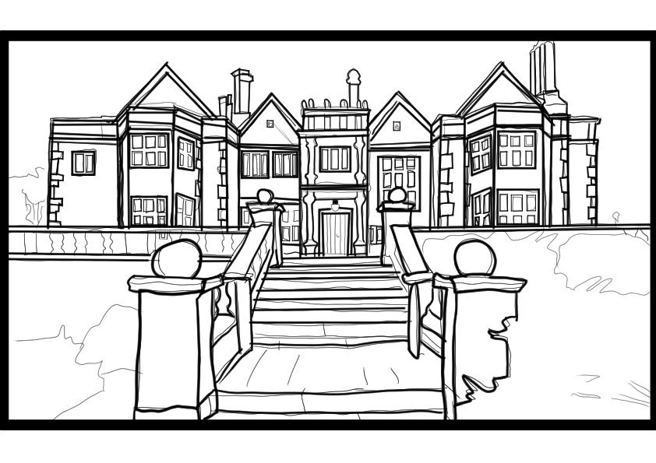
Draw below your favourite part and colour in!

