|  |  |
| --- | --- |
|  | **BOROUGH OF HYNDBURN**  **HOME OF THE ACCRINGTON PALS**    **PLANNING & TRANSPORTATION SERVICES**  Scaitcliffe House  Ormerod Street  Accrington  BB5 0PF  Contact Centre: 01254 388111 |

Notice of an Application to modify or discharge a Planning Obligation under Section 106A of The Town and Country Planning Act 1990

Please complete the form in block capitals using black ink.

Please use this form when applying for the modification or discharge of a planning obligation with Hyndburn Borough Council.

For further information please refer to the Town and Country Planning (Modification and Discharge of Planning Obligations) Regulations 1992. <http://www.legislation.gov.uk/uksi/1992/2832/made>

|  |  |  |  |
| --- | --- | --- | --- |
| **1. Type of application:** | |  |  |
| Are you applying to **modify** a planning obligation? | | Yes | No |
| Are you applying to **discharge** a planning obligation? | | Yes | No |
| **2. Your details** |  | | |
| Name |  | | |
| Address |  | | |
| Post Code |  | | |
| Email address: |  | | |
| Daytime tel. number |  | | |
| **3. Agent details if applicable** |  | | |
| Name |  | | |
| Address |  | | |
| Post Code |  | | |
| Email address: |  | | |
| Daytime tel. number |  | | |
| **4. Full postal address of the site to which the obligation relates:** | | | |
|  | | | |
| **5. Nature of the applicant’s interest in the land:** | | | |
|  | | | |
| **6.** Please provide sufficient information to enable us to identify the planning obligation **(Planning reference number(s), the date of signing the obligation, and the particular obligation(s) to be modified/changed:** | | | |
|  | | | |

|  |
| --- |
| **7. What reason(s) do you have for applying for the modification or discharge of the obligation?** |
|  |

|  |  |  |
| --- | --- | --- |
| **Signed –Applicant** | **Or signed – Agent** | **Date (DD/MM/YYYY** |
|  |  |  |

|  |  |
| --- | --- |
| **Checklist:** | **Please tick** |
| A 1 copy of this form, signed and dated |  |
| B 1 copy of an OS licensed map identifying the land to which the obligation relates. |  |
| C 1 copy of any other relevant information **(including any prescribed notices issued as below)** |  |
| D If submitting other than via the Planning Portal or email an electronic copy of the application on CD or USB memory stick |  |

Please note that the information provided on this application form and in supporting documents may be published on our website and provided to members of the public in responses to Land Searches.

If you require any further clarification please contact the Hyndburn BC Planning Department. We may check information on this form for the prevention or detection of crime/fraud. We may also share this information with other bodies responsible for auditing or administering public funds for these purpose, but will not disclose information about you to anyone outside the Council unless the law permits us to do so.

The Council’s full privacy statement can be viewed at <https://www.hyndburnbc.gov.uk/privacy-notice/>

We are registered as a data controller under the Data Protection Act 2018. We are responsible for managing the information we hold about you and we recognise that the accuracy and security of this information is important to you. We take our responsibilities seriously and always strive to use your personal information fairly, correctly and safely in line with legal requirements.

The Data Controller is Hyndburn Borough Council. We are registered with the Information Commission and our registration number is Z2090478.

The Statutory Instrument can be viewed at <http://www.legislation.gov.uk/uksi/1992/2832/made>

The Part 1 Notice **has** to be served by the applicant on any interested third parties **21 days prior** to making the application, or published in a newspaper if the third party is unknown:

Regulation 4(5)

SCHEDULE

PRESCRIBED NOTICES AND CERTIFICATES

PART 1

NOTICE OF AN APPLICATION TO MODIFY OR DISCHARGE A PLANNING OBLIGATION UNDER SECTION 106A OF THE TOWN AND COUNTRY PLANNING ACT 1990

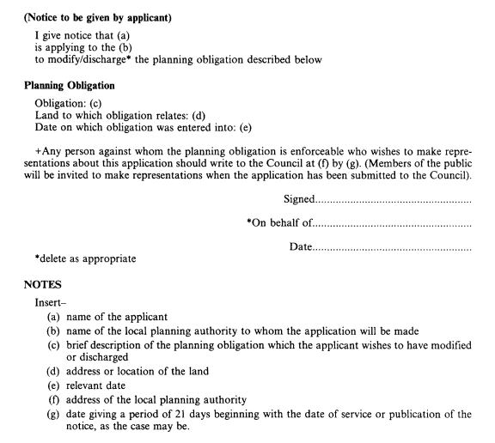

**The applicant has to complete the relevant section below when submitting to Hyndburn Borough Council**

**PART 2**

**Regulation 4(5)**

**CERTIFICATE OF COMPLIANCE WITH THE NOTIFICATION REQUIREMENTS IN REGULATION 4**

**Certificate A**

I certify that on the day 21 days before the date of the accompanying application the planning obligation to which the application relates was enforceable against nobody other than the applicant.

Signed........................................................

On behalf of.......................................................

Date.......................................................

**Certificate B**

I certify that the applicant has given notice to everyone else against whom, on the day 21 days before the date of the accompanying application, the planning obligation to which the application relates was enforceable, as listed below.

Person on whom notice was served

Address at which notice was served Date on which notice was served

Signed........................................................

On behalf of.......................................................

Date.......................................................

**Certificate C**

I certify that:

-the applicant cannot issue a Certificate A or B in respect of the accompanying application;

-the applicant has given notice to the persons listed below, being persons against whom, on the day 21 days before the date of the application, the planning obligation to which the application relates was enforceable Person on whom notice was served

Address at which notice was served Date on which notice was served

Signed........................................................

On behalf of.......................................................

Date.......................................................

* The applicant has taken reasonable steps to ascertain the name and address of every person against whom, on the day 21 days before the date of the application, the planning obligation to which the application relates was enforceable and who has not been given notice of the application but has been unable to do so. These steps were as follows - (a)
* Notice of the application, as attached to this certificate, has been published in the (b) on (c)

NOTES

1. description of steps taken
2. name of local newspaper in which the notice was published (c) date of publication.