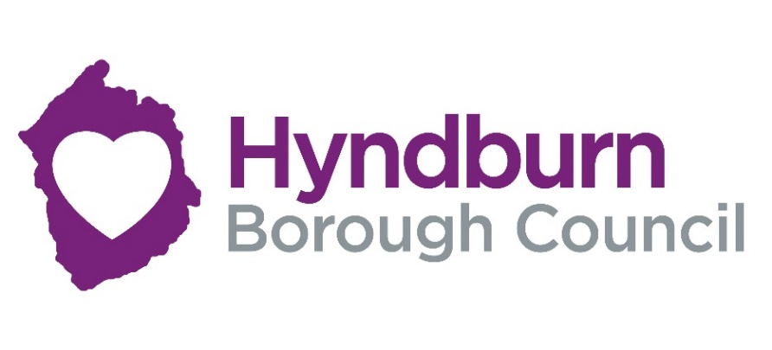

Business Startup Grant application form
Hyndburn Borough Council is providing grants of up to a maximum of £2,000 to help with starting a business.
Eligibility for Start-up Grant - If you are looking to start up a new business in Hyndburn you may be eligible for match funded grant of up to a maximum of £2,000. IE you will need to invest an amount equivalent to the grant amount applied for as a minimum. Example £2,000 grant will equate to £2,000 private sector investment requirement.
The council are looking to support businesses ideas which demonstrate sustainability, growth and innovation.
Businesses are required to be at Pre-start stage or trading for less than 12 months.
CIC’s and social enterprises are eligible to apply if they have a trading arm.
Grant funding can be used to support the following activity.
Purchase of fixtures & fittings, equipment, marketing, specialist consultancy.
Not eligible websites. Computers /ipads /phones, vehicles, stock purchase, salaries and working capital.

**Please note that we cannot accept hand written applications**

Section 1
Applicant details
Name
Home Address
Contact number
Email address

Section 2
Business details
Name of business

Business trading address

Is this business currently trading or at Pre –start stage.

If the business is trading please complete section 2A. If No then please go to section 2B

Section 2A
Complete by a business already trading
Date trading commenced
Trading format I.e. sole trader/ limited company/partnership/CIC
Are you VAT Registered? If Yes, what is your VAT number?
Trading address

Do you have a business lease? Yes How long is your business lease

Website details

Social media details

Detail about the business- Please provide a brief description of your business activity (max 150)

What is the current business turnover since trading commenced?
What was the net profit for the period of trading (approx.)
What amount of grant funding are you applying for?

Please provide details of what the grant funding will be used for?

What will be the source of the match funding investment? Eg own capital, loan etc.

Section 2B
completed by pre-start businesses
Pre- Start business- when do you expect to commence trading (evidence of trading will be required before grant is paid )

Business name

Business trading address

Do you have a business lease? Yes How long is your business lease

Website details
Social media details
Detail about the business- Please provide a brief description of your business activity (max 150)

What amount of grant funding are you applying for?
Please provide details of what the grant funding will be used for?

What will be the source of the match funding investment? Eg own capital, loan etc.

Section 3
All businesses to complete
Will your business create any further jobs within the next 12 months? | Yes/No  If yes provide details
Which product or service will your business be providing?

Will your business be adopting any digital technology? | Yes/No  If yes provide details
Are you launching a product or service that does not currently exist in the market? This means the product or service is fundamentally different in design or technology to already existing products and services? | Yes/No  If yes provide details

Section 4
Quotations
The councils procurement rules state that a minimum of 2 quotations must be submitted for all products and services which you are applying for grant funding. Eg shelving, 2 quotes from different suppliers. Please submit quotations with your application.

Section 5
State Aid Declaration
In order to comply with State Aid rules, companies need to declare the value of any public sector state aid assistance within the last 3 years.  Has your company received any state aid as detailed above? | Yes/No  If Yes please complete section 5A, If no please go to section 6

Section 5A
State aid amount received?

Name of organization

Name of project or scheme

Date state aid received

Section 6
Check List of documents required
2 quotations for each product or service.

Completed supplier selection matrix

Business Plan

Cash flow forecast

Business lease if applicable

Business Insurance

Copy of companies house reg if Limited company

HMRC UTR number if sole trader

If you are unable to submit any of the above documents for eg business insurance if you are still at Pre-start stage, this will need to be provided prior to a grant being paid.

Payment for grant awards will be made retrospectively, Ie once the project is complete and evidence of payment has been provided.

Grant awards will only be paid into a business bank account.

Section 7
Questions and queries

If you have any questions relating to this form or the grant application process please contact the Council’s Economic Development team: email business@hyndburnbc.gov.uk

