HYNDBURN Local Plan timetable
June 2026
- Introduction

  - This Local Plan timetable covers the administrative area of Hyndburn, Lancashire, as outlined in red on the plan below. The Local Plan will cover the entirety of the administrative boundary of Hyndburn Borough Council (ONS E07000120).

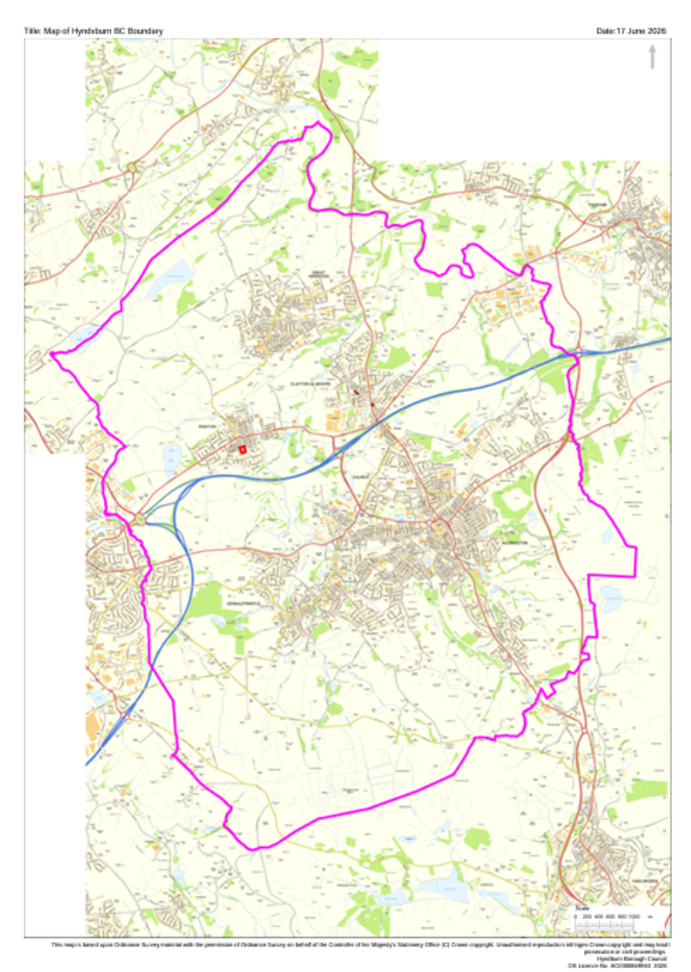

  - The Local Plan Timetable has been prepared in accordance with the requirements of The Planning and Compulsory Purchase Act (as amended) 2004 and the Town and Country Planning (Local Planning) (England) Regulations 2026.

  - The Local Plan will cover the following matters:

- Vision and Objectives;
- Local planning policies where they relate to local matters;
- Site allocations;
- Local Plan Policies Map.

- Local Plan Timetable Process

  - The Local Plan making process is set out below. The formal stage of plan making is required to be completed within 30-months.

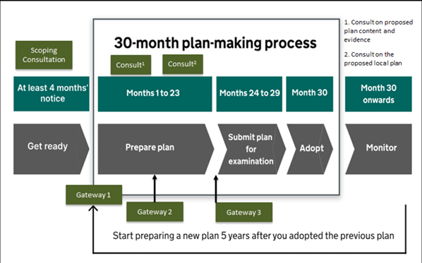
  - The Council is required to publish a Notice of Intent to commence plan-making at least four months before the start of the formal 30-month plan preparation period. Under the Regulations, Hyndburn Borough Council must publish its Notice of Intent by 30 June 2026. During this initial preparatory stage, the Council will publish a Local Plan Timetable and undertake a scoping consultation to seek views on matters including the content of the Plan and the approach to future stakeholder and community engagement throughout the plan-making process.

  - Gateway 1 marks the start of the 30-month plan making period. For Gateway 1, local planning authorities are required to prepare and publish a self-assessment summary which sets out details of their local plan preparation.

  - After Gateway 1 a consultation is carried out on the proposed local plan content and evidence, including the following:

- a proposed vision for the local planning authority’s area and proposed measurable outcomes
- any proposed aims and objectives of the local planning authority, including how they propose to achieve the vision
- a proposed spatial strategy approach
- a summary of the local planning authority’s proposed approach in relation to planning policies (which could include proposed site allocation policies)
- a summary of the evidence intended to support the local plan
- any further supporting information the local planning authority considers appropriate

  - After publishing a summary of that consultation, the Plan can then proceed to Gateway 2 where the local planning authority seeks observations and advice from an appointed assessor, including:

- progress towards preparing a sound plan, in line with the tests of soundness set out in the National Planning Policy Framework;
- meeting some of the Gateway 3 prescribed requirements; and
- what further work could be carried out by the local planning authority.

  - A copy of the information submitted as part of the assessment and the gateway assessor’s report must be published online and made available for inspection.

  - A final consultation is then undertaken on the proposed local plan and supporting submission documents, including:

- the proposed local plan document
- the map of proposed local plan policies
- details of the evidence gathered to support the proposed local plan
- details relating to the scoping consultation and consultation on proposed local plan content and evidence, including a summary of the main issues raised by respondents and how those main issues have been addressed in the proposed local plan

  - The local planning authority can make any amendments to the plan before progressing to Gateway 3, where an appointed assessor provides observations on whether the prescribed requirements set out in the regulations are met in relation to the proposed local plan.

  - When the Gateway 3 assessor concludes that the proposed local plan meets the prescribed requirements, then the local planning authority must submit it for independent examination.

  - The purpose of the examination is to determine whether it is reasonable to conclude that the Local Plan is sound, in line with the tests of soundness set out in the National Planning Policy Framework.

  - Where the appointed examiner identifies that further work is required for the plan to be sound, and decides that the examination is to be paused, the regulations state that the maximum length of the pause is 6 months.

  - The local planning authority must publish the recommendations and reasons received from the examiner as soon as is reasonably practicable after receipt and notify any person who requested to be notified of this.

  - Subject to the recommendations of the examiner, the local planning authority will then proceed to adoption of the Plan.

- The Local Plan Timetable

  - Set out below are the key milestone dates of the Local Plan. Also in the timetable are two key dates in connection with Local Government Review which takes effect in Lancashire on the 1 April 2028.

  - The Government template for the Local Plan Timetable is published on the Council`s New Plan-Making System – Hyndburn Borough Council

Milestones | Description | Target Dates
Notice of Intent to Commence Plan-Making. | Publication of the notice brings the local plan timetable into effect. | 30 June 2026
Report to Council | Report setting out the scoping of the Plan and seeking approval to go out for the Scoping consultation – the scoping document contains draft vision and objectives and how the Council is going to consult on the Plan. | Council Meeting (16 July 2026)
Scoping Consultation | 6-week public consultation inviting feedback on what the plan should contain and how we should engage when further consultations take place. | 14 August 2026 – 11 September 2026
GATEWAY 1 Self-Assessment | Publication of a document confirming the plan-making preparation to date, marking formal commencement of the 30-month timeframe to prepare and adopt the local plan. Includes publication of the Scoping Consultation Summary and Self-Assessment. | 31 October 2026
Report to Council | Report seeking approval to go out for public consultation on the Plan content, vision and objectives, draft spatial strategy. | October 2027
Consultation on Notice of Plan Content, Vision and Objectives, draft Spatial Strategy and evidence the Council is going to gather and already has | This second formal consultation sets out the proposed vision, aims and objectives, spatial strategy, evidence we have already gathered and evidence we intend to gather and the scope and details of the Strategic Environment Assessment. This consultation will also include information about proposed policies topics, potential allocations and constraints. | 2 November 2027 – 14 December 2027
Analysis of the responses from the consultation | - | 15 December 2027 – 1 March 2028
LOCAL GOVERNMENT REVIEW – VESTIING DAY – 1 APRIL 2028 – NEW UNITARY AUTHORITY TAKES OVER THE LOCAL PLAN PROCESS
GATEWAY 2 Assessment | Seeking observations and advice, from an external assessor, to support the early resolution of potential soundness issues with the emerging plan and evidence base including progress towards the requirements required to pass Gateway 3 (the ‘prescribed requirements’). | 5 April 2028
Report to Council | Seek approval of Draft Local Plan and request to go out for public consultation. | June 2028
Notice of Proposed Local Plan Consultation | 6-week consultation on the final version of the local plan and its supporting documents. | 2 June 2028 – 14 July 2028
Analysis of the responses from the consultation |  | 14 July 2028 – 8 October 2028
GATEWAY 3 Assessment | Final check, by an external assessor, that the proposed local plan has met the ‘prescribed requirements’ and can proceed to examination. | 1 November 2028 – 1 February 2029
Date of Submission to Secretary of State for Examination | The proposed Local Plan is submitted for an independent Examination carried out by a Planning Inspector. | 1 April 2029
Report to Council | Seek approval for adoption of the Plan | October 2029
Adoption |  | 1 November 2029
*Mandatory tasks are coloured purple in the above table

