 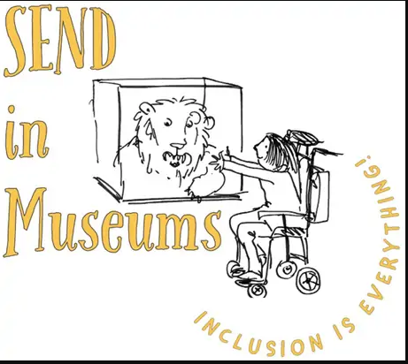

**Haworth Animal safari**

Find 5 animals. They might be in a vase, in pictures or as decorations around the house.

**Which is the largest, smallest, funniest, scariest?**

**Pretend to be one of the animals and make its sound.**

*Mew loves to hunt for animals*

*She counts them in their dozens.*

*And only gets a litle scared*

*if she meets her big cat cousins!*