 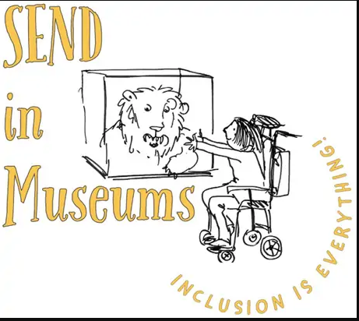

**Let’s pretend**

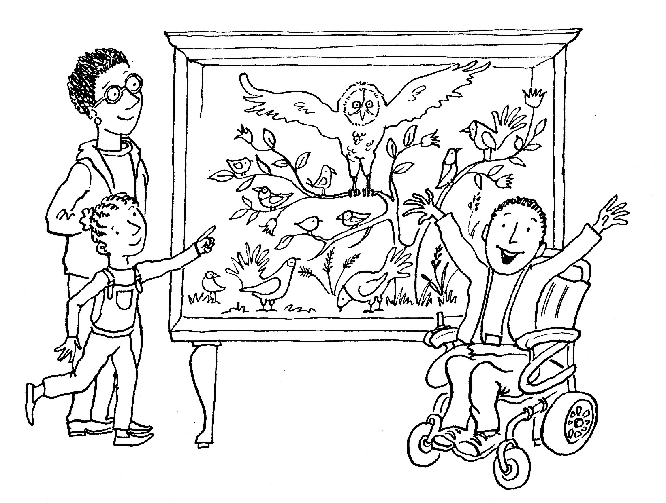

Choose an object. Pretend to be it, using sounds and actions. Can your family or friends guess what you are? You could become a mouse in the Billiard room, an owl on the roof, or even a teapot in our dining room!